# Capacity Reservation

https://docs.aws.amazon.com/AWSEC2/latest/UserGuide/ec2-capacity-reservations.html

* Create a Capacity Reservation to reserve compute capacity for your instances in a specific Availability Zone for any duration.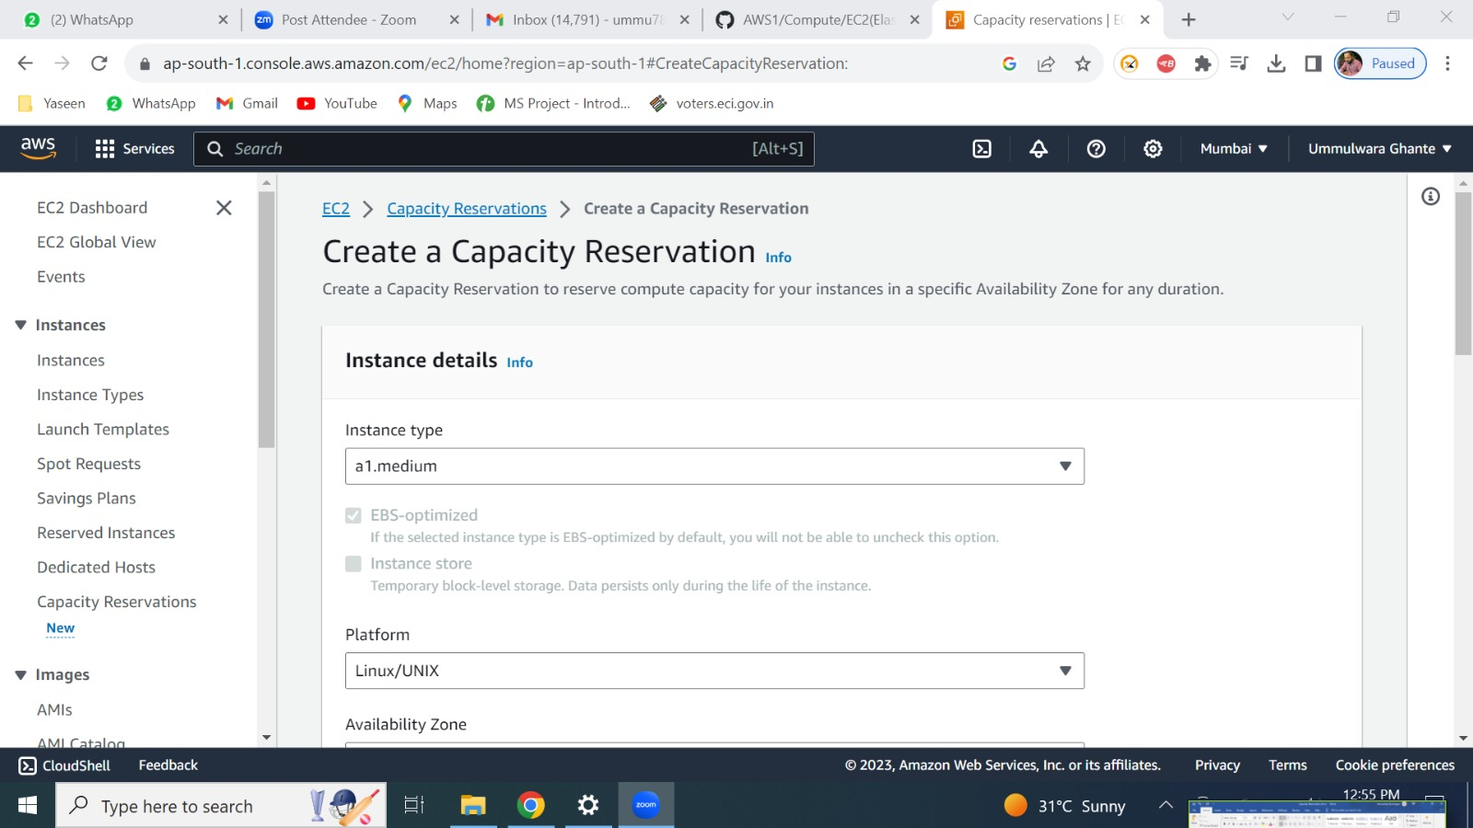



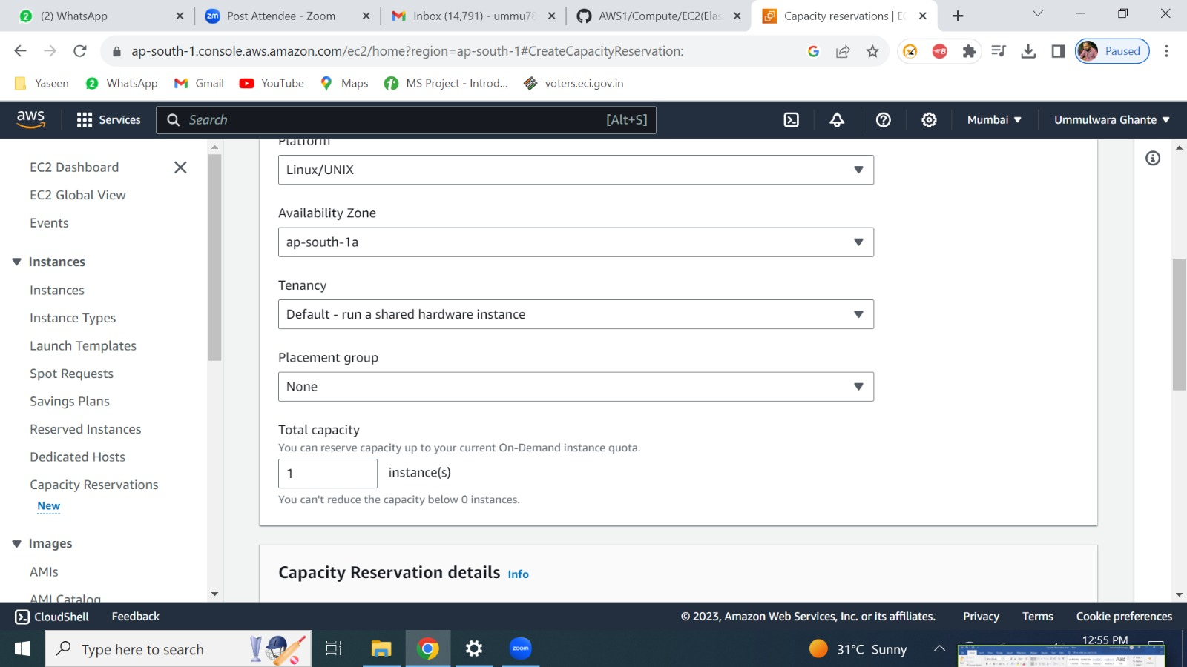



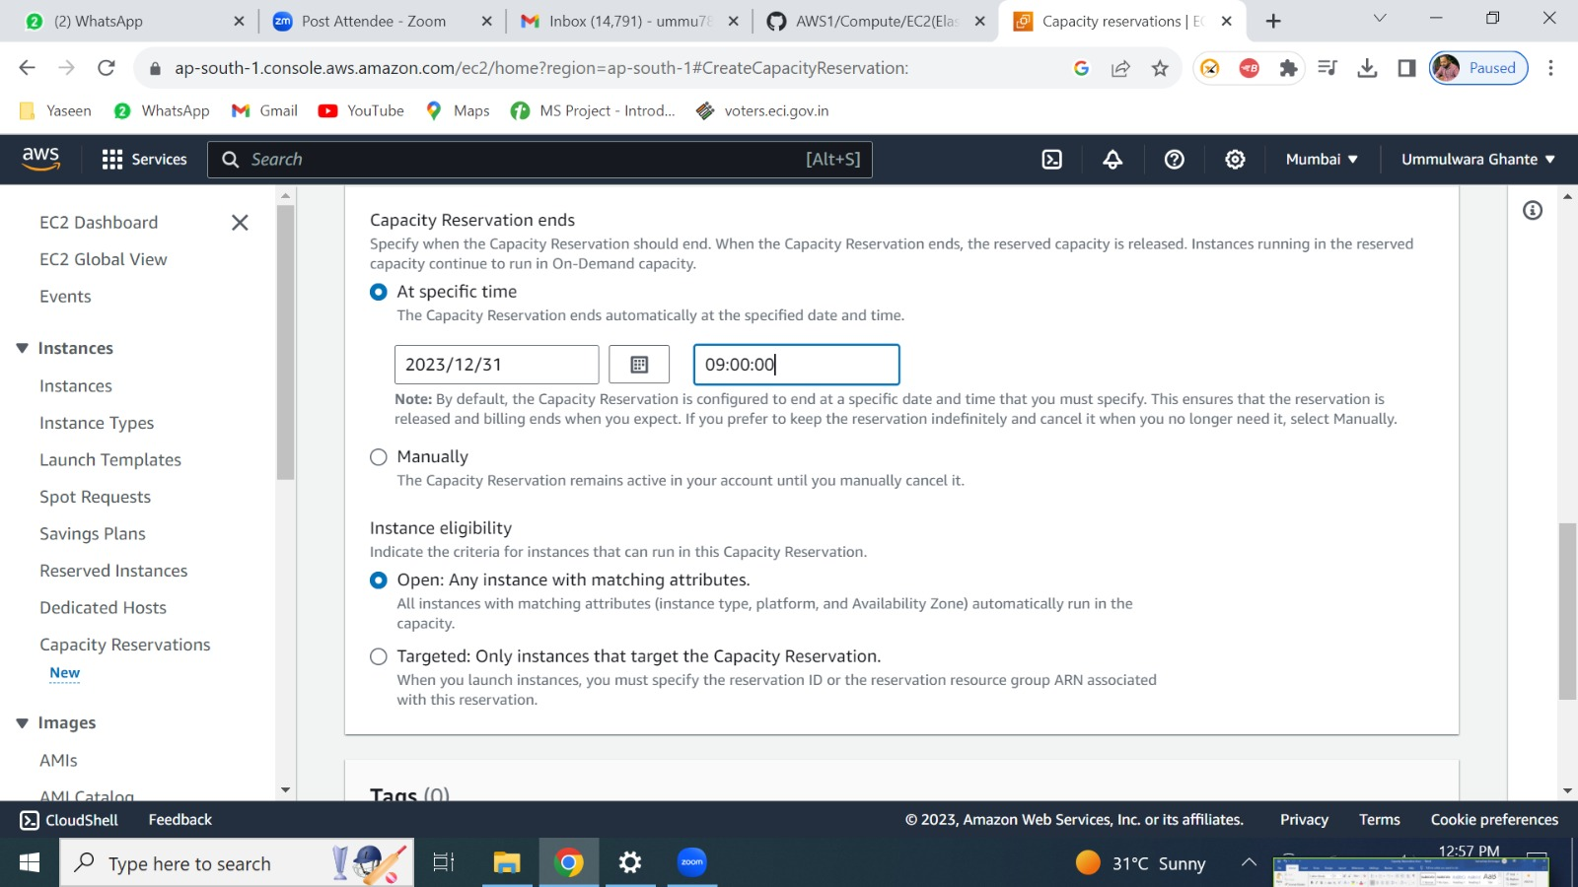



Here you provide specific date and time at which in future you need to cancel this capacity reservation.(this will be cancelled automatically in future)

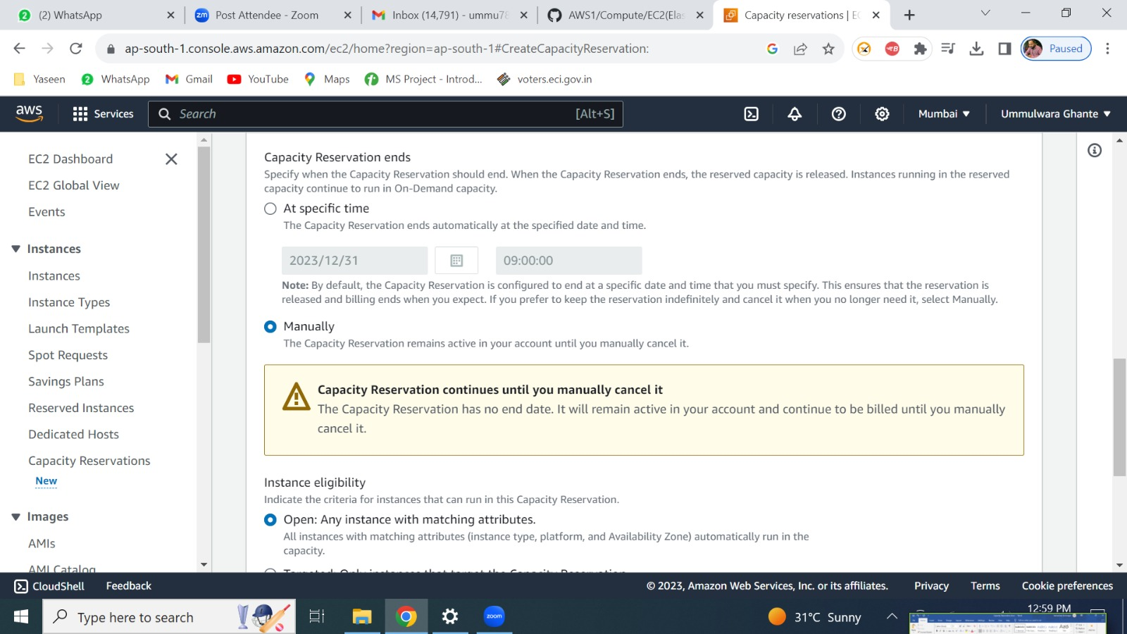



This capacity reservation will end when you will manually cancel it.

**Theory**

* You are reserving the required capacity (no of instances, duration, type of instance etc.)
* No commitment in terms of duration (e.g.,1 or 3 years) as you can remove the capacity reservation at any time.
* Specifications of CR: AZ, no of instances, tenancy, OS, Platform, instance type, placement group etc.)
* In CR we have two options at a specific time or manually.

**Cost**

* AWS will charge or the capacity whether you are using it or not.
* You will be billed as soon as capacity reservation is applied and will be stopped as soon as you stop the capacity reservation.
* Capacity Reservations are charged at the equivalent On-Demand rate whether you run instances in reserved capacity or not.
* If you do not use the reservation, this shows up as unused reservation on your Amazon EC2 bill.
* When you run an instance that matches the attributes of a reservation, you just pay for the instance and nothing for the reservation.
* There are no upfront or additional charges.
* E.g., If you reserve 10 instances of specified attributes and you use only 7 instances then you need to pay bill for 7 used instances (no need to pay for reservation cost) but you also need to pay for 3 unused instances (need to pay for reservation cost).

**Note:**

* **You can terminate CR at any point of time**
* **No discount**
* **Savings Plans are not applied to CR**